

Research Report

Integration of Starlink with Home Networks

- College: College of Computing
- Major: Computer Science
- Supervisor: Man Hon Cheung
- Student Name: CHEN Xian
- Student Number: 5XXXXX

Starlink, developed by SpaceX, is a massive low earth orbit satellite internet constellation designed to provide high-speed, low latency network services globally, especially to remote areas where traditional fiber optics are difficult to reach. Its basic operating principle is illustrated in Figure 1, through thousands of satellites in near earth orbit, using advanced laser links for high-speed data relay. This enables signals from ground gateways connected to the backbone network to be accurately transmitted to users’ Starlink terminals (Dishes) and routers, thereby overcoming geographical limitations and achieving true integrated space to ground connectivity.
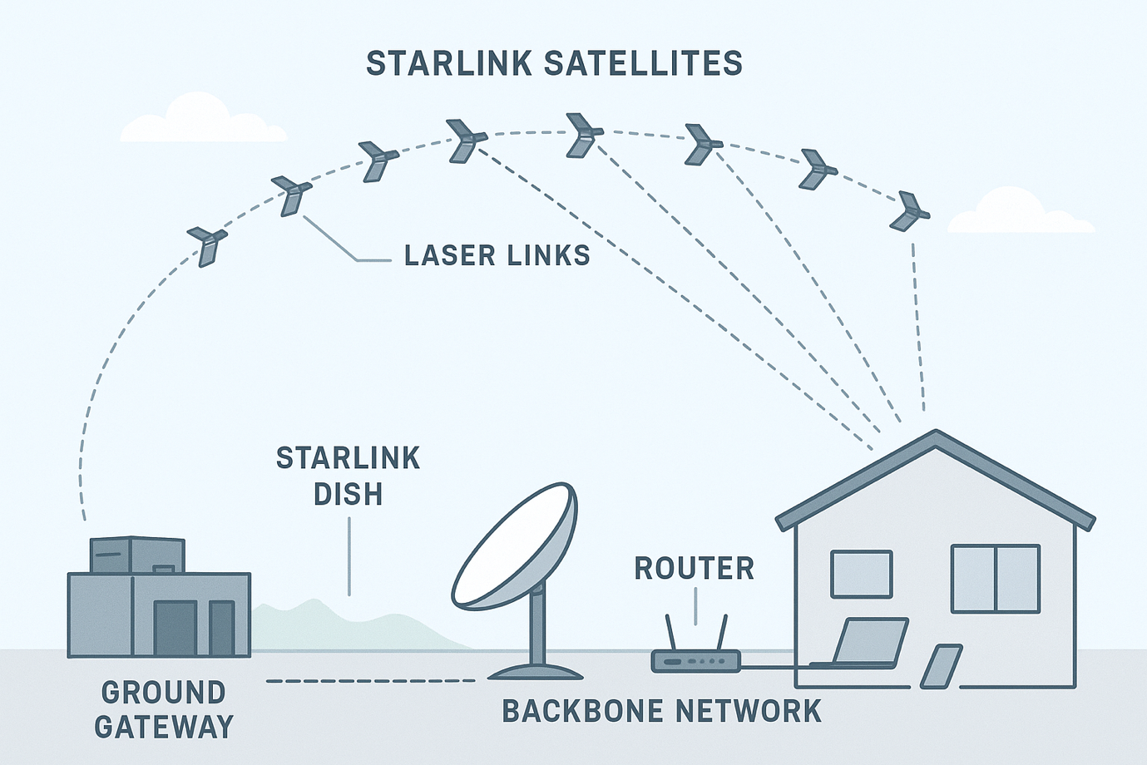
Figure 1: the system forms a vast “mesh network”
I first came across Starlink [1] a few years ago when the news frequently reported that SpaceX was launching large numbers of low-orbit satellites. Those reports emphasized the grand vision of “providing high-speed internet access anywhere in the world”, but I didn’t have a deep understanding of how it differed from traditional satellite internet. It wasn’t until recently, when I saw many outdoor enthusiasts on online platforms livestreaming smoothly from wilderness areas, snowy mountains, and deserts using Starlink, that I realized this technology is no longer distant. I then watched user review videos and discussions on technical forums and noticed that quite a few people have begun integrating Starlink with their home routers as an alternative to home broadband. Therefore, I chose the topic “Integrating Starlink with Home Networks” to analyze its technical features, challenges, and future development from the perspective of the course content.
In traditional home broadband systems, internet service providers must lay extensive ground infrastructure: underground and community fiber optic ducts, communication rooms distributed across various locations, and weak current boxes and distribution panels in building corridors, all connecting users to the operator’s core network. In urban areas, the high population density allows the cost of laying fiber to be spread out, but in regions with complex terrain, such as rural areas, mountains, or islands, the difficulty and cost of fiber construction rise sharply, and coverage may even be impossible. This means that traditional broadband is inherently constrained by geographical conditions and the capacity for infrastructure deployment.
Starlink works in a completely different way. Users only need to install a small antenna outside their residence, which automatically adjusts its angle to connect to the nearest low orbit satellite. The entire process does not rely on local fiber or ground communication infrastructure. This “airborne link” bypasses all the expensive, slow, and geographically constrained ground components, enabling broadband access to break free from infrastructure limitations for the first time.
In the past, satellite networks were often associated with high latency and low speeds, which are inherent limitations of traditional geostationary satellites. However, Starlink uses low Earth orbit (LEO) satellites at an altitude of approximately 550 kilometers, drastically reducing the data transmission distance compared to the traditional 36,000 kilometers, thereby significantly improving latency. In real-world experience, Starlink’s round-trip latency usually stays between 20 and 40 milliseconds, approaching the typical values of fiber networks. Downlink speeds generally range from 100 to 250 Mbps and can be higher in low-congestion areas or with commercial plans; uplink speeds are mostly in the range of 10 to 30 Mbps [2], sufficient to meet the daily upload needs of most home users. Overall, Starlink’s performance is already capable of supporting a full household network, no longer limited to simple web browsing like traditional satellite links.
The entire Starlink system is roughly composed of user terminals, the low earth orbit satellite constellation, and ground gateways with the core network. The user terminal, also known as the Starlink Dish, contains a built-in phased-array antenna that can automatically track satellites and serves as the wide-area network entry point for a home network [3]. Its role is like an optical network terminal (ONT) in traditional fiber broadband, a high-speed fixed-line modem, or a 5G CPE. Therefore, whether using the official router provided by Starlink or connecting the Dish to a personal router system in “bypass mode”, it always represents the first hop between the home network and the global Starlink system.
In the space segment, hundreds to thousands of Starlink low earth orbit satellites are constantly moving and interconnect with each other via laser links, forming a highly dynamic airborne network topology. These satellites must maintain link connections while moving at high speeds and quickly switch communication paths if a link is broken or its quality degrades. The ground segment includes Starlink’s gateway stations and core network. Satellites downlink data to the ground gateways, which then enter Starlink’s backbone network and subsequently route the data to the public internet.
When integrating Starlink with a home network, the characteristics of the link layer are particularly important. Because the link itself is wireless and requires switching between different satellites, latency and jitter are more susceptible to fluctuations than in fiber networks. During satellite handovers, brief packet loss may occur. In addition, the round-trip time (RTT) can vary significantly, typically ranging from 25 to 60 milliseconds. These characteristics put pressure on link-layer error recovery mechanisms, causing ARQ or hybrid ARQ to trigger more frequently, and directly affecting the experience of real-time applications such as gaming and voice calls.
At the transport layer, although Starlink’s RTT is much lower than that of traditional satellites, it is still noticeably higher than fiber. As a result, TCP’s slow start process tends to be longer, and the bandwidth delay product is higher. If the congestion window does not expand in time, the available bandwidth may not be fully utilized. Occasional packet loss caused by satellite handovers can also trigger TCP retransmission timeouts, temporarily reducing transmission speed. At the transport layer, although Starlink’s RTT is much lower than that of traditional satellites, it is still noticeably higher than fiber. As a result, TCP’s slow-start process tends to be longer, and the bandwidth-delay product is higher. If the congestion window does not expand in time, the available bandwidth may not be fully utilized. Occasional packet loss caused by satellite handovers can also trigger TCP retransmission timeouts, temporarily reducing transmission speed.
Due to the scarcity of IPv4 addresses [4], Starlink does not provide public IPv4 addresses to home users by default. Instead, it uses Carrier-grade NAT [5], assigning users to the 100.64.0.0/10 address range. In this setup, the home router performs the first NAT, and the Starlink network core performs the second NAT, creating a double NAT structure. This prevents users from performing port mapping, making services like home NAS, cameras, or self-hosted VPNs inaccessible from the public internet. To overcome these limitations, Starlink offers native IPv6 [4] support and assigns a /56 prefix, allowing home users to allocate globally routable IPv6 addresses to internal devices, thus restoring end to end reachability. However, for IPv6 to work correctly, users need to configure third-party routers appropriately, including using DHCPv6, explicitly requesting the /56 prefix, and selecting the correct LAN configuration mode.
When using Starlink as a home network access method, several practical issues need to be considered. First, the user terminal must have a sufficiently unobstructed view of the sky. If the installation location is blocked by buildings or trees, it can cause signal degradation, sudden increases in latency, or brief disconnections. Therefore, home users need to choose optimal installation points such as rooftops, balconies, or yards and address outdoor cabling requirements. What’s more, Starlink’s bandwidth can fluctuate at different times, depending on local user density, satellite load, and gateway coverage. During busy network periods, downlink speeds may decrease noticeably. For households relying on numerous IoT devices or streaming multiple high-resolution streams, internal traffic management and QoS mechanisms [6] need to be planned carefully. Additionally, to ensure home mesh systems (such as AiMesh, Deco, or UniFi) function properly, users typically need to enable bypass mode, allowing Starlink to act solely as a modem while the home router manages all internal network functions.
Starlink’s technology roadmap is still evolving. As the number of satellites continues to increase, link density will become higher, coverage will become more uniform, and latency is expected to further decrease to below 20 milliseconds. With improvements in the stability and throughput of inter-satellite laser links, Starlink’s space backbone network will become more mature, potentially reducing reliance on traditional submarine cable routes. On the other hand, as IPv6 support continues to improve, home users will find it easier to overcome the limitations imposed by CGNAT and achieve true end to end communication. Starlink is also collaborating with operators to advance non-terrestrial network technologies for direct mobile connections, enabling ordinary smartphones to communicate with satellites even without base station coverage.
In the future, home networks may no longer rely on fixed antenna devices, instead achieving seamless, ubiquitous connectivity through a fusion of 5G and satellite access. Overall, Starlink is not merely another form of broadband access; by replacing “ground infrastructure” with an “airborne link,” it introduces a new paradigm at the network architecture level. For areas where fiber coverage is difficult or for users requiring high mobility, Starlink offers unprecedented access freedom and demonstrates an alternative vision for the future of internet infrastructure.

References
- Michel F, Trevisan M, Giordano D, et al. A first look at starlink performance[C]//Proceedings of the 22nd ACM Internet Measurement Conference. 2022: 130-136.
- WANG Jingxian,YU Zhigang,ZHU Chao,et al.Analysis of Starlink System Service Capabilities[J].Space-Integrated-Ground Information Networks,2024,05(03):3-10. DOI： 10.11959/j.issn.2096-8930.2024022.
- Grinter R E, Edwards W K, Newman M W, et al. The work to make a home network work[C]//ECSCW 2005: Proceedings of the Ninth European Conference on Computer-Supported Cooperative Work, 18–22 September 2005, Paris, France. Dordrecht: Springer Netherlands, 2005: 469-488.
- Wu P, Cui Y, Wu J, et al. Transition from IPv4 to IPv6: A state-of-the-art survey[J]. IEEE Communications Surveys & Tutorials, 2012, 15(3): 1407-1424.
- Jiang S, Guo D, Carpenter B. An incremental carrier-grade NAT (CGN) for IPv6 transition[R]. 2011.
- What Is Quality Of Service (QoS) In Networking? Available online: https://www.fortinet.com/resources/cyberglossary/qos-quality-of-service (accessed on 21 November 2025).

